**Reading Comprehension**

Reading Comprehension (also known as Critical Reading) questions test your ability to understand a passage and answer questions on the basis of what is stated and implied in the passage. You need to read the passage first so that you can identify the main idea of the passage and appreciate features such as the author's tone and attitude as well as the organization of the passage. Scroll back to the relevant point in the text as you do each question.

Critical readers are a lot like crime scene investigators. In their search for the truth, they do not let opinions sway them; they want to know what actually happened. They collect tangible evidence and facts and use this information to draw an informed conclusion. Separating fact from opinion is essential during a crime scene investigation. It is also a crucial skill for effective reading.

When you read, look for clues to understand the author’s meaning. What is this passage about? What is this writer saying? What is his or her message? At times, it may seem like authors are trying to hide their meaning from you. But no matter how complex a piece of writing may be, the author always leaves plenty of clues for the careful reader to find. It is your job to find those clues. Be a good detective when you read. Open your eyes and ask the right questions. In other words, read carefully and actively.

The following lesson covers the basics of reading comprehension. By the end of this section, you should be able to:

* Find the basic facts in a passage
* Determine the main idea of a passage
* Determine the meaning of unfamiliar words from context
* Distinguish between fact and opinion

**Passage 1**

On Friday, October 21, at approximately 8:30 a.m., Judith Reynolds, owner of The Cupcake Factory, arrived at her establishment to find that it had been robbed and vandalized overnight. The front window of the shop at 128 Broad Street was broken, and chairs and tables were overturned throughout the café area. Additionally, the cash register had been pried open and emptied of money. The thieves attempted to open the safe as well, but were unsuccessful. Ms. Reynolds used her cell phone to report the crime to the police. She also phoned the proprietor of Primo Pizza, located at 130 Broad Street, as she noticed that the door of that restaurant showed signs of forced entry. The police department is asking anyone with information to call 555-2323.

**1.** What happened to The Cupcake Factory?

**2.** When was the crime discovered?

**3.** Where did it happen?

**4.** What was stolen?a

**5.** Who called the police?

**6.** What other businesses were affected?

Remember, good reading is active reading. Did you identify the important clues in the passage? If so, it may have looked something like this:

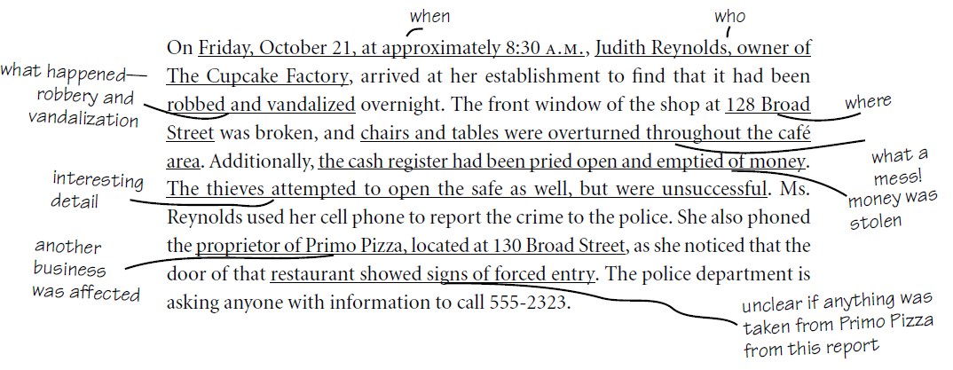

The answers to the questions have all been underlined, because these are the key words and ideas in this passage. But here are the answers in a more conventional form.

1. What happened to The Cupcake Factory?

It was robbed and vandalized.

1. When was the crime discovered?

At 8:30 A.M. on

Friday, October 21.

1. Where did it happen?

128 Broad Street.

1. What was stolen?

Money from the cash register.

1. Who called the police?

Judith Reynolds, owner of The Cupcake Factory.

**6.** What other businesses were affected? Possibly

Primo Pizza.

1. ***Read the following passage carefully and answer the questions that follow****.*

Education has always had two objects: on the one hand, to give skill; and on the other, to impart a vaguer thing which we may call wisdom. The role of skill has become very much larger than it used to be and is increasingly threatening to oust the role of wisdom. At the same time it must be admitted that wisdom in the our world is useless except for those who realize that great part played by skills, for it is increase of skill that is the distinctive feature of your world.

Although scientific skill is necessary, it is by no means sufficient. A dictatorship of men of science would very soon become horrible. Skill without wisdom may prove to be purely destructive. For this reason, if for no other, it is of great importance that those who receive a scientific education should not be merely scientific, but should have some understanding of that kind of wisdom which, if it can be imparted at all, to know can only be imparted by the cultural side of education. Science enables us the means to any chosen end, but it does not help us to decide upon what ends should be pursued. If you wish to exterminate the human race, it will show you how to do it. If you wish to make the human race so numerous that all are on the very verge of starvation, it will show you how to do that. If you wish to secure adequate prosperity for the whole human race, science will tell you what you must do. But it will not tell you whether one of these ends is more desirable than another. Nor will it give you that instinctive understanding of human beings that is necessary if you measures are not to arouse fierce opposition which only ferocious tyranny can quell. It can teach you patience, it cannot teach you sympathy, it cannot teach you a sense of human dignity. These things, insofar as they can be taught in formal education, are most likely to emerge from the learning of history and great literature.

**Bertrand Russell**

From:*Fact**and**Fiction*1960

**Questions**

* 1. What should, according to the writer, be the aim of education?
  2. Why is increase of skill a distinctive feature of our world?
  3. What danger does the writer see in the present emphasis on imparting skill?
  4. What knowledge does science impart to us?
  5. Why should we study history and great literature?
  6. What is the distinction between ‘knowledge’ and ‘wisdom’? Can the latter be imparted?
  7. Does the present system of Indian education take care of the viewpoints of Russell? Explain your view, giving two or three illustrative examples.

1. **CLOZE TEST**

DISCUSSION:

Do you know the meaning of a cloze test?

What is the significance of taking a Cloze test?

QUESTIONS

1. Fill the blanks with appropriate words ( remember to fill only one word per blank)

Happiness is not a destination___________ you need to reach. You _______________ define happiness. You cannot decide __________________ make a person happy. One _______________ to be happy in any_______________. Decide to be happy in_______________. Redefine your happiness and make _____________________ your way of life.

2. Rude behavior at work is ______________ and is on the rise. _______________ can take several forms and ________________ times arises due to thoughtlessness _____________ than actual malice. Nearly everybody _____________________ experiences work place incivility responds____________________ a negative way, in some cases overtly retaliating.

HOMEWORK

**Read the following passage and answer the questions given below:**

A slave named Androcles once escaped from his master and fled to the forest. As he was wandering about there he came upon a Lion lying down moaning and groaning. At first he turned to flee, but finding that the Lion did not pursue him, he turned back and went up to him. As he came near, the Lion put out his paw, which was all swollen and bleeding, and Androcles found that a huge thorn had got into it, and was causing all the pain. He pulled out the thorn and bound up the paw of the Lion, who was soon able to rise and lick the hand of Androcles like a dog. Then the Lion took Androcles to his cave, and every day used to bring him meat. But shortly afterwards both Androcles and the Lion were captured, and the slave was sentenced to be thrown to the Lion, after the latter had been kept without food for several days. The Emperor and all his Court came to see the spectacle, and Androcles was led out into the middle of the arena. Soon the Lion was let loose from his den and rushed bounding and roaring towards his victim. But as soon as he came near to Androcles he recognised his friend, and fawned upon him, and licked his hands like a friendly dog. The Emperor, surprised at this, summoned Androcles to him, who told him the whole story. Whereupon the slave was pardoned and freed, and the Lion let loose to his native forest.

**Answer the following questions:**

1. Why Androcles at first attempted to run away from the Lion?

2. What had happened to the Lion?

3. Why did the Lion lick the hand of Androcles?

4. Why was Androcles captured by the Emperor?

5. What do you learn from the story? Justify your answer.